**How to transfer files in BeyondTrust**

1. You need to use BeyondTrust desktop client. If you use the BeyondTrust link to login, on the right side, you can download and install the desktop version.

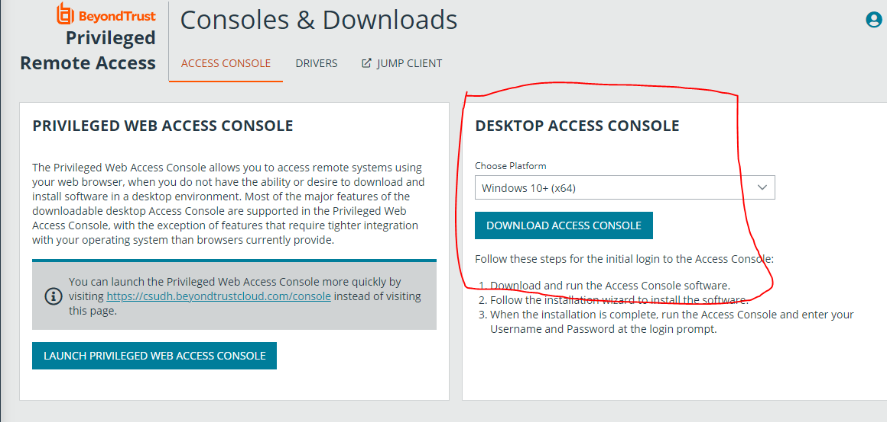

1. Once you complete installing the desktop version, login BeyondTrust, remote to your server. Click on the File Transfer tab.



1. Have fun BeyondTrust-ing.